**Experiment 04**

**Aim: Implementation of Linear Regression for Single Variate and Multi-variate**

**Part A:** Program Single variate using inbuilt functions.

**Code:**

import matplotlib.pyplot as plt

import numpy as np

from sklearn import datasets, linear_model

from sklearn.metrics import mean_squared_error

diabetes = datasets.load_diabetes()

diabetes_X = diabetes.data[:,np.newaxis,2]

diabetes_X_train = diabetes_X[:-30]

diabetes_X_test = diabetes_X[-30:]

diabetes_y_train = diabetes.target[:-30]

diabetes_y_test = diabetes.target[-30:]

model = linear_model.LinearRegression()

model.fit(diabetes_X_train, diabetes_y_train)

diabetes_y_predicted = model.predict(diabetes_X_test)

plt.scatter(diabetes_X_test, diabetes_y_test)

plt.plot(diabetes_X_test, diabetes_y_predicted)

plt.show()

**Output:**

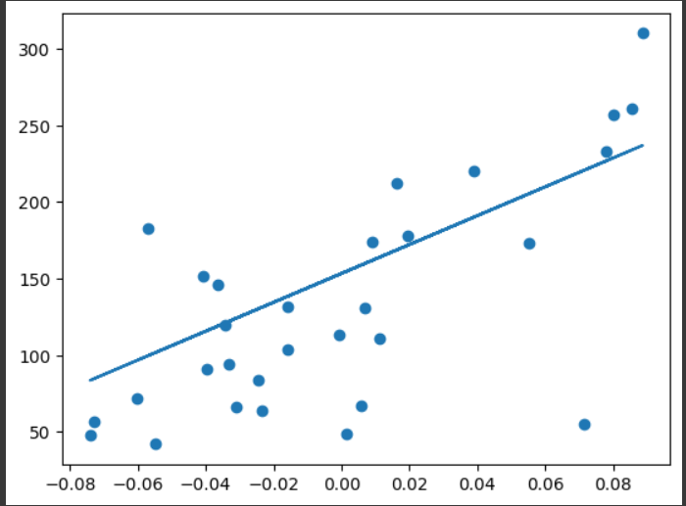

**Part B:** Program Multi variate using inbuilt functions.

**Code:**

import matplotlib.pyplot as plt

import numpy as np

from sklearn import datasets, linear_model

from sklearn.metrics import mean_squared_error, r2_score

diabetes_X, diabetes_y = datasets.load_diabetes(return_X_y=True)

diabetes_X = diabetes_X[:, np.newaxis, 2

diabetes_X_train = diabetes_X[:-20]

diabetes_X_test = diabetes_X[-20:]

diabetes_y_train = diabetes_y[:-20]

diabetes_y_test = diabetes_y[-20:]

regr = linear_model.LinearRegression()

regr.fit(diabetes_X_train, diabetes_y_train)

diabetes_y_pred = regr.predict(diabetes_X_test)

print("Coefficients: \n", regr.coef_)

print("Mean squared error: %.2f" % mean_squared_error(diabetes_y_test, diabetes_y_pred))

print("Coefficient of determination: %.2f" % r2_score(diabetes_y_test, diabetes_y_pred))

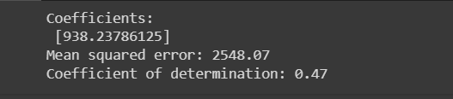**Output:**